Document History

Revision History
Revision | Date | Summary of Changes | Author
1 | 2016/01/26 | Initial Design | Erik Nedwidek
2 | 2017/04/11 | Documented introduction of ExecutorService | Erik Nedwidek

Reference Documents
Document Name | Version | Author
Twilio General Process Flow.xmind | 1 | Erik Nedwidek
Database – Emergency.xmind | 1 | Erik Nedwidek

Summary

Introduction
My employer used a text message relay system to announce late starts or being closed for the day due to inclement weather. A text message would go out to all department managers and they would forward the message to their employees.
Issues would arise when managers did not notice the text message or when an employee was left off the forwarded message.
Removing the human error factor would be ideal.

Solution
Use the Twilio programmable message service to buy a local OBX phone number that can accept SMS messages. Messages sent to this number by a member of an authorized group, such as VR Managers, should be forwarded to all employees. Additionally the message can be started with a group tag to indicate what group of employees it should be forwarded to.
Groups can be added to the system by inserting new records into the database.

Drawbacks
- SMS is not guaranteed delivery.
- SMS is hold and relay. Messages may be delayed.
- Cell service providers are not prohibited from filtering SMS service. SMS messages are not always delivered to recipients.
- Twilio has monthly charges for phone numbers and text messages sent/received.

Solution Implementation

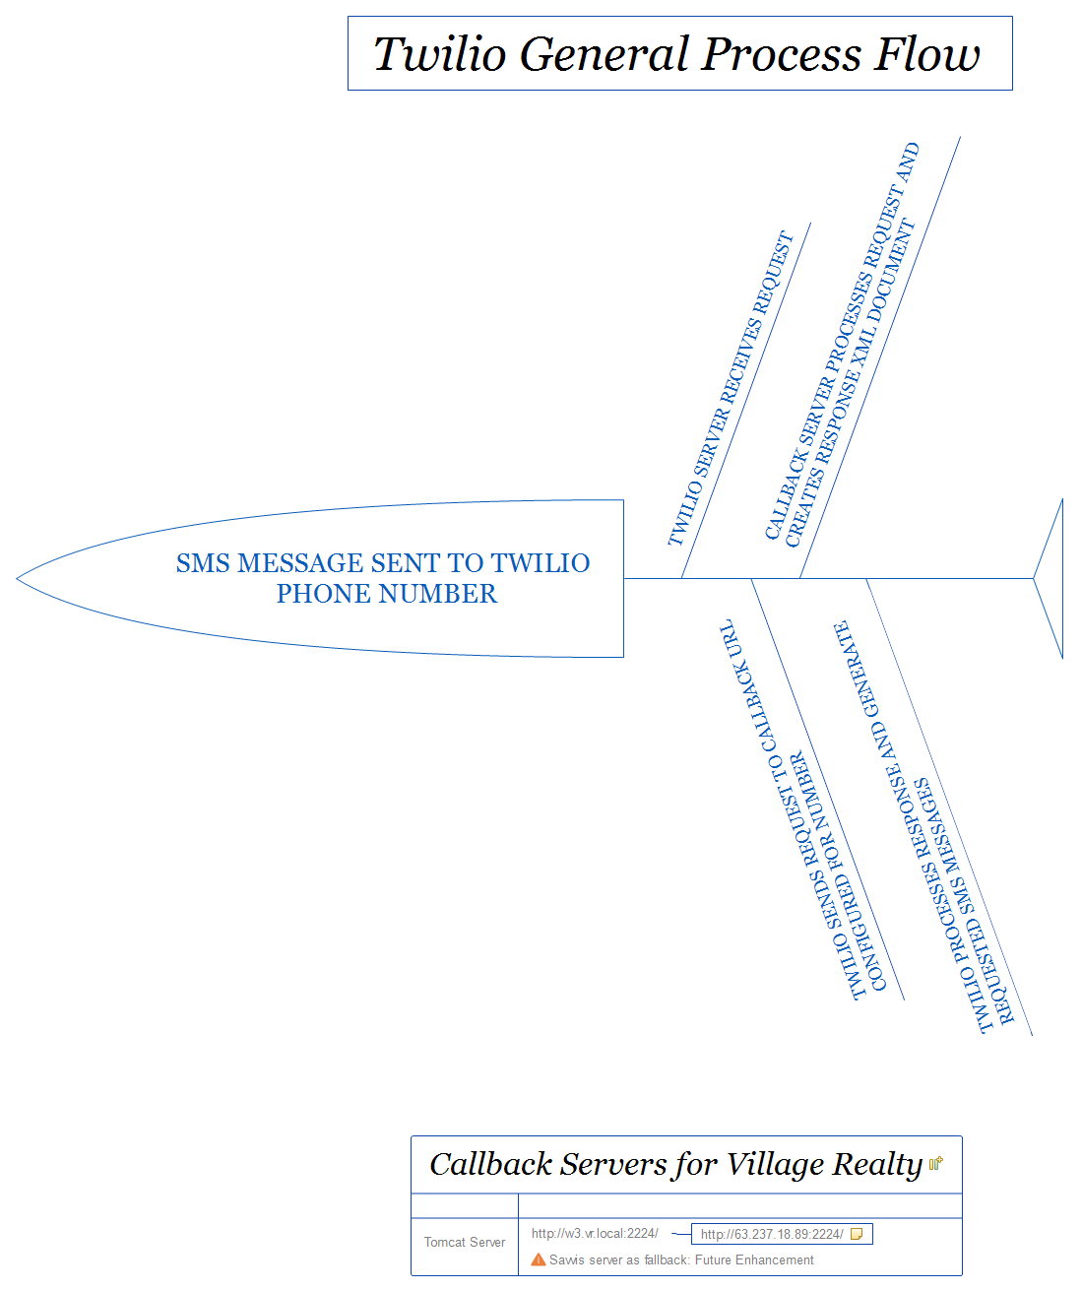
Twilio
Twilio accepts the SMS message and generates a POST or GET request to the registered callback URL. That URL generates an XML response document indicating any messages to be sent.

Database
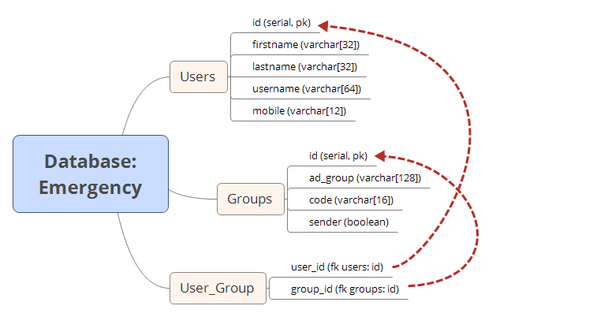
Database engine is PostgreSQL and the database is emergency.
This database is shared with the GoDaddy 2FA Forwarder Application.
The users table is populated with all Active Directory users that have a defined mobile number and whose accounts are not disabled.
The groups table is populated with the AD groups that we are interested in. The column sender is a boolean value. It indicates that members of that group are authorized to send messages to the system for forwarding to employees.
The user_group table is a join table.
There are two user roles. emergency_user is used with the cron job and has full privileges. emergency_tomcat is used with the servlets and is limited to SELECT. The SQL files to create the database tables and add the groups are in the database directory. Each file can be executed by the postgres user with the command:
psql -d emergency -f <filename>
Files should be executed in the following order:
- users_and_db.sql
- tables.sql
- codes.sql
- privileges.sql

Cron Job
A java program called AD_Loader.class is run from the crontab on each database server. It first queries the AD Domain Controller vr-ad01 via LDAP for all users and their group memberships. It updates the users table (INSERT, UPDATE, DELETE) and updates group membership for the groups defined in the groups table.
The cron job requires the postgresql-jdbc3.jar to be in the classpath. It also requires the Java JRE 7 or greater as try-with-resources is used for freeing database resources.
The cronjob can be built by make target, cronjob. It is deployed along with the servlet by the deploy target.
Edit root's crontab to contain:
10 10,14,18 * * * export CLASSPATH=/usr/share/java/postgres-jdbc3.jar:/usr/local/emergency && /usr/bin/java AD_Loader

Tomcat
Tomcat 7 is used as the Java EE server. The EmployeeContact.class servlet is mapped to the URI sms under the eecontext context.
Database connection pooling is used. Verify that the tomcat-dbcp jar is in /usr/share/java. If Tomcat was packaged without this jar, it can be obtained with the following command as root:
wget -O /usr/share/java/tomcat-dbcp-7.0.30.jar http://search.maven.org/remotecontent?filepath=org/apache/tomcat/tomcat-dbcp/7.0.30.jar
Copy the /etc/tomcat/context.xml file to /etc/tomcat/Catalina/localhost/eecontact.xml. Add the following XML to the Context node.
<Resource name=”jdbc/postgres” auth=”Container” type=”javax.sql.DataSource”
driverClassName=”org.postgresql.Driver” url=”jdbc:postgresql:emergency”
username=”emergency_tomcat” password=”<your password>” maxActive=”20”
maxIdle=”5” maxWait=”-1” />
Java JRE 7 or greater is needed as try-with-resources is used for freeing the DB connection.
Twilio has a limit of 21 messages in a TwiML document. The response to the sender will be sent via the TwiML response. The message sent to each employee will be sent via the Twilio REST API. Twilio also only holds the connection for open for a limited time. If our server does not close the connection before this timeout, the TwiML will not be processed by Twilio and an error will be logged in the Twilio dashboard. Our server will send all of the messages to the employees, but this situation is not ideal. To overcome this limitation, the service method passes the Twilio message to an ExecutorService, outputs the TwiML document, and returns.
Full over view of the process. At server start, the servlet’s init method reads the init parameter threadPoolSize and creates an ExecutorService with that many threads.
When Twilio receives a message, it calls the defined callback URL. The servlet’s service method processes query string parameters sent by Twilio. A DB connection is opened and the sender is validated. If they are not authorized, a TwiML message is returned to them saying, “Unauthorized sender.”
If they are authorized, the message is checked to see if they sent ‘?’ or ‘help’. If they did, a TwiML message is returned giving them help on using the system and all defined group tags and the AD group they refer to. If they did not ask for help, their message is submitted to the ExecutorService to be processed on another thread and a TwiML message is returned to to let the sender know that the server is working on the request.
In the ExecutorService the message is checked for a group tag. The presence of a group tag is indicated by a colon (:) anywhere in the first 10 characters of the message body. The validity of the group tag is not checked as the sender will receive a message indicating that the message was forwarded to 0 users.
The message sent to each employee mobile number is in the format:
Message from XXXXXXXXX (<Sender's first and last names>)
<Body Parameter>
This is an automatically generated message. Please do not respond.

A message is also sent to the original sender prepended with:
Sent the following message to <numRecipients> users.
And followed by the message sent to the employees.

Build Environment

Requirements
Java JDK 7 or greater
Tomcat 7 or greater
Gnu Make

Build Instructions
Adjust any variables in the Makefile
Execute the command “make && make deploy”.
Upon successful build the context will be deployed to Tomcat and the Tomcat service will be restarted. The cron job will be deployed to /usr/local/emerrgency. Deployment steps will execute under sudo.
Deployment does not edit the crontab for root. See the section Cron Job under Solution Implementation for directions on scheduling the cron job if needed.

